Join and union
1.Join
Create table in sql database
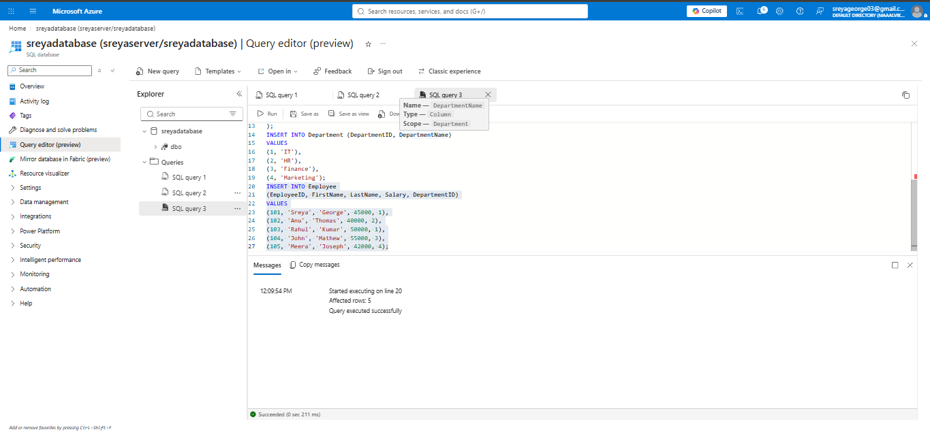
-- ---------- Table 1: Department ----------
CREATE TABLE dbo.Department (
DeptID INT NOT NULL PRIMARY KEY,
DeptName VARCHAR(50) NOT NULL,
Location VARCHAR(50) NULL
);

INSERT INTO dbo.Department (DeptID, DeptName, Location) VALUES
(10, 'HR', 'Kochi'),
(20, 'Finance', 'Bangalore'),
(30, 'IT', 'Chennai'),
(40, 'Marketing', 'Mumbai'),
(50, 'Operations', 'Hyderabad'); -- no employees here (shows inner join dropping it)

-- ---------- Table 2: Employee ----------
CREATE TABLE dbo.Employee (
EmpID INT NOT NULL PRIMARY KEY,
EmpName VARCHAR(50) NOT NULL,
Salary DECIMAL(10,2) NULL,
DeptID INT NULL -- links to Department.DeptID
);

INSERT INTO dbo.Employee (EmpID, EmpName, Salary, DeptID) VALUES
(101, 'Arun', 45000.00, 10),
(102, 'Divya', 52000.00, 20),
(103, 'Rahul', 60000.00, 30),
(104, 'Sneha', 48000.00, 30),
(105, 'Faisal', 55000.00, 40),
(106, 'Meera', 47000.00, 10),
(107, 'Kiran', 50000.00, NULL); -- no department (shows inner join dropping it)

-- ---------- Verify ----------
SELECT * FROM dbo.Department;
SELECT * FROM dbo.Employee;

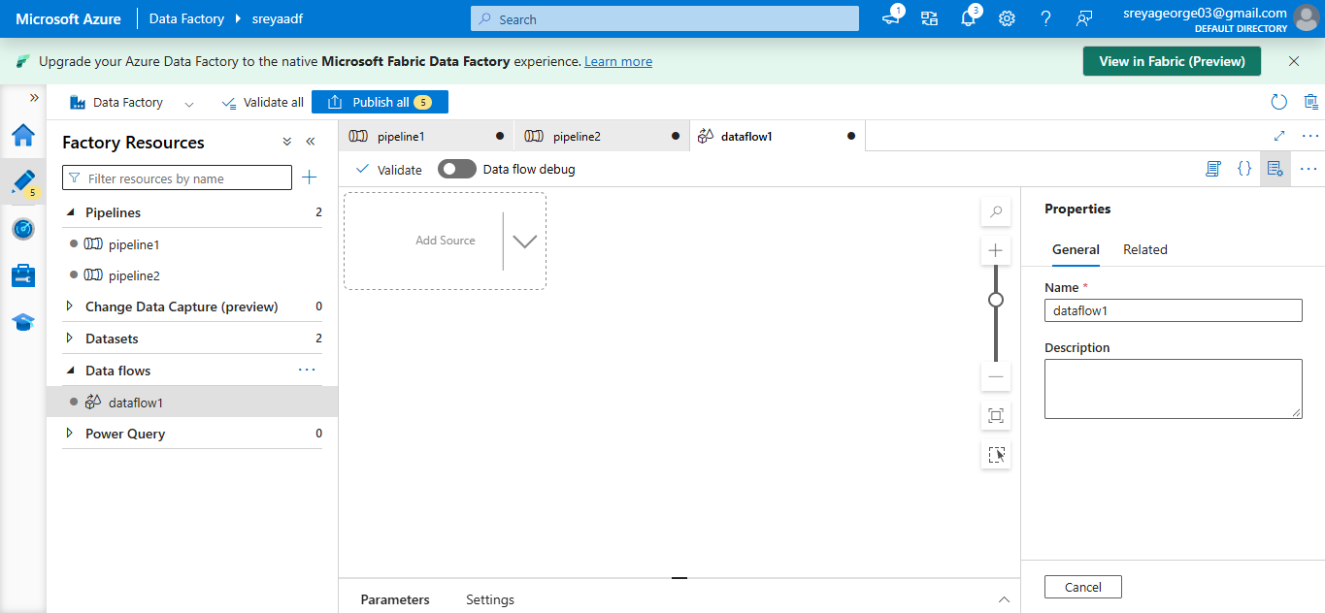
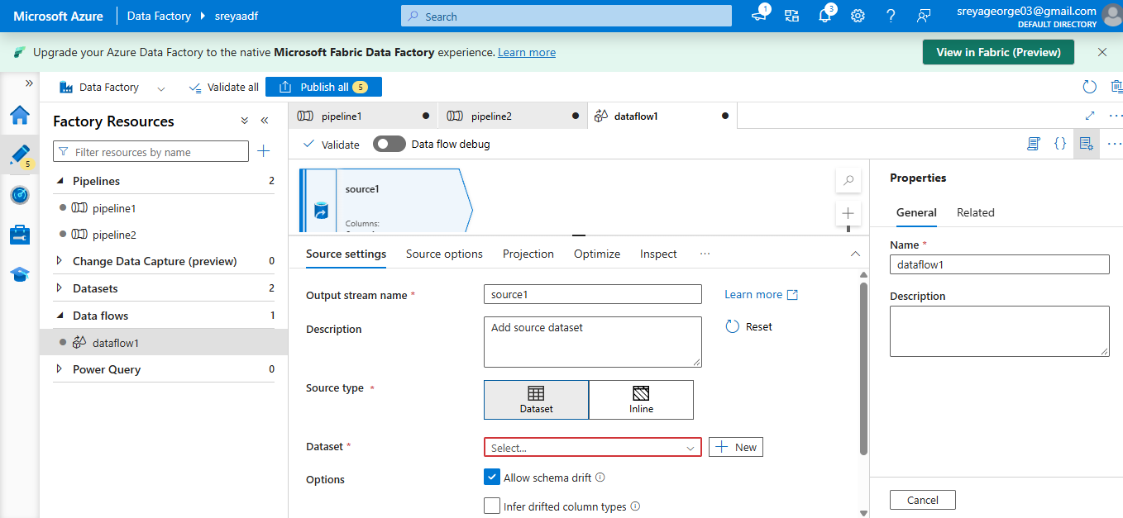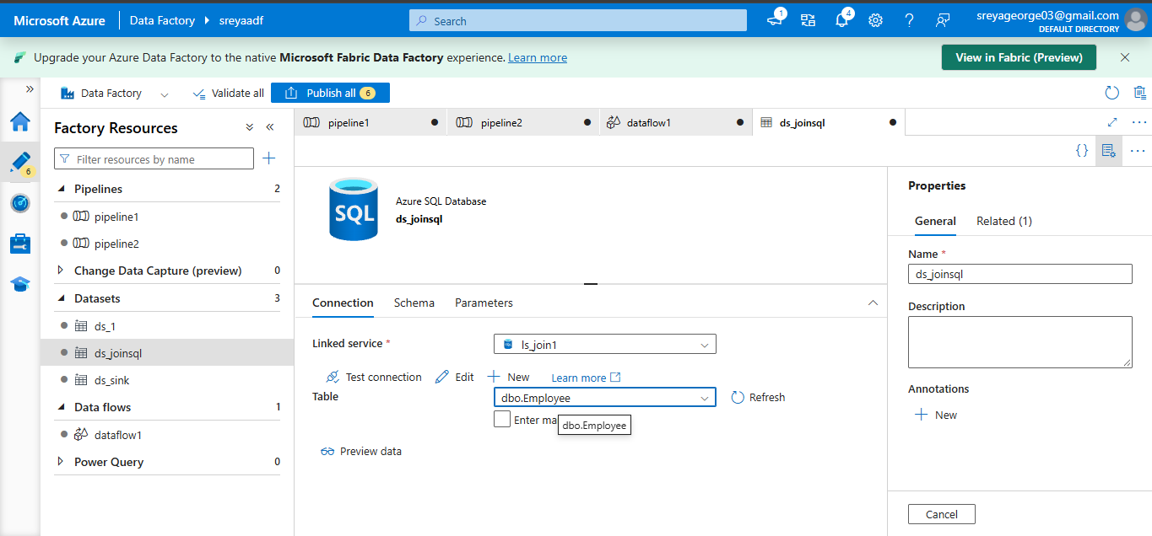
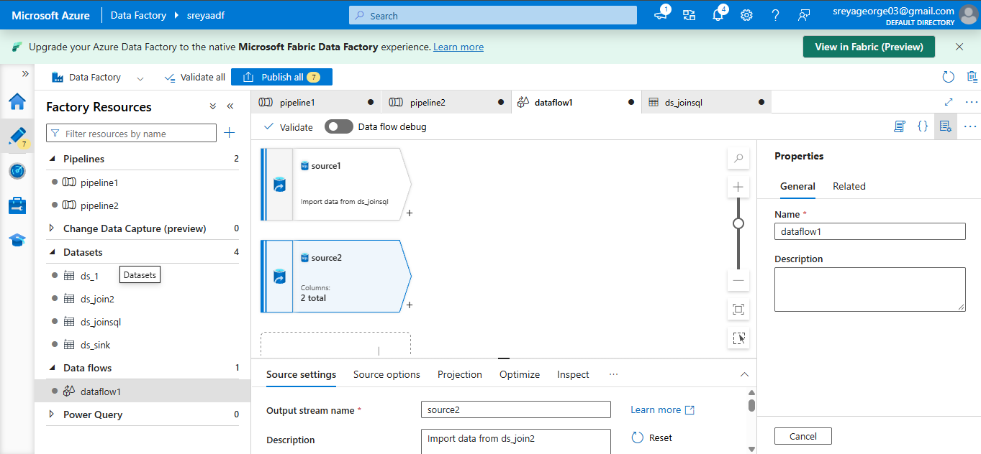
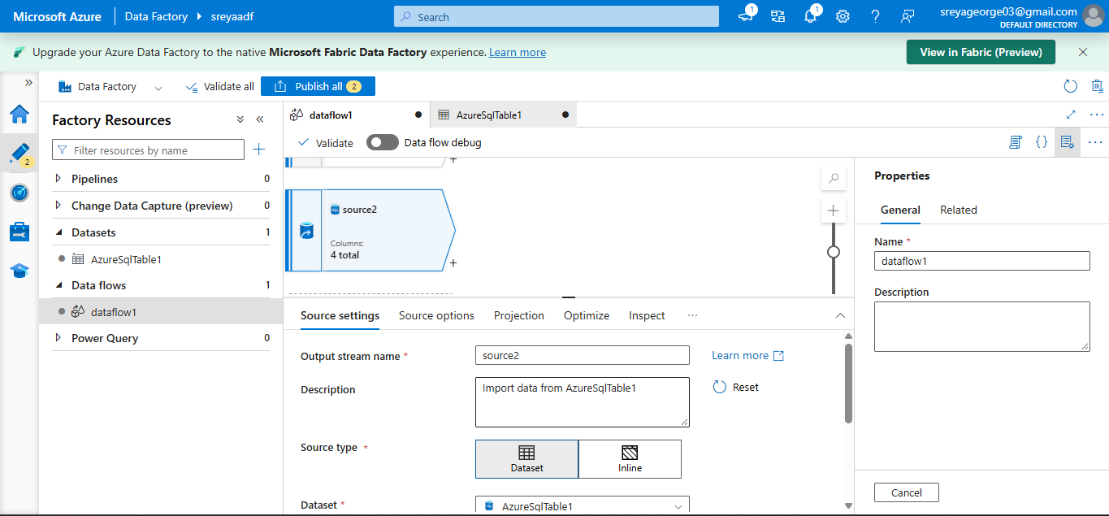
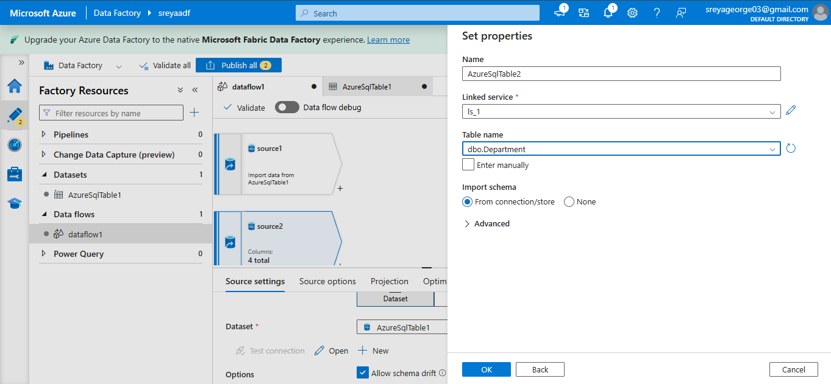

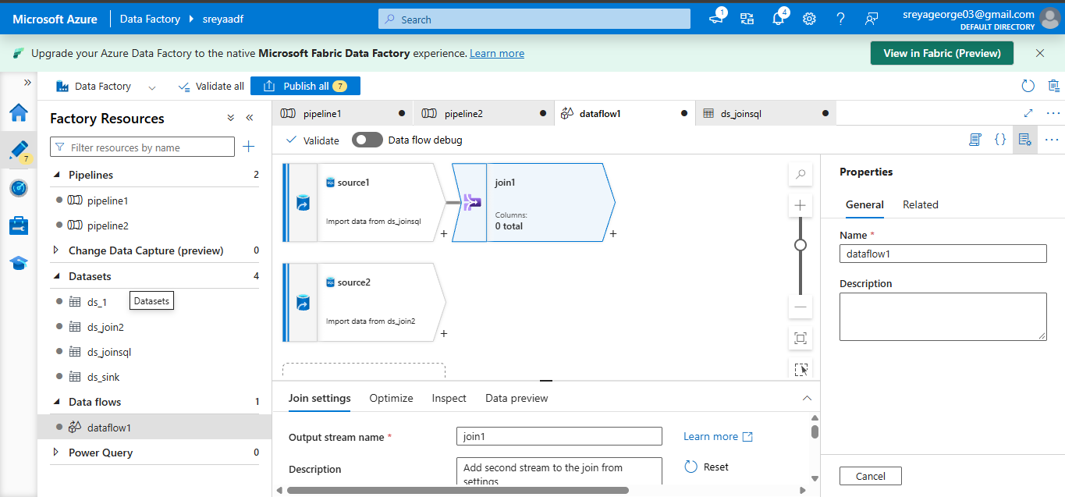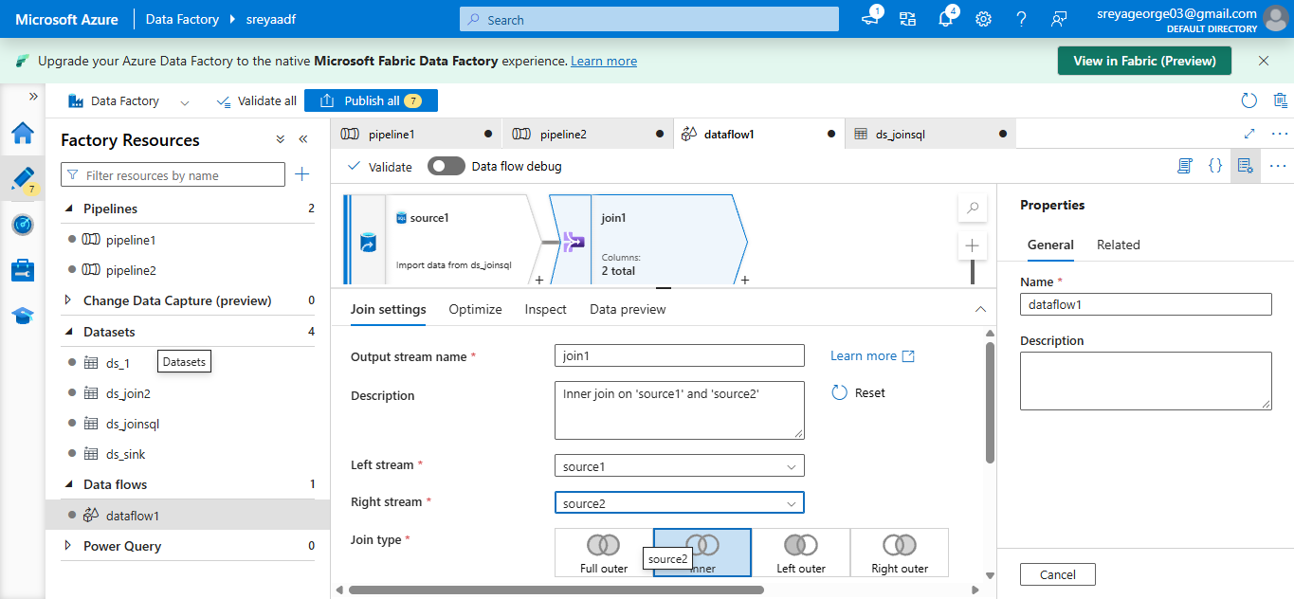
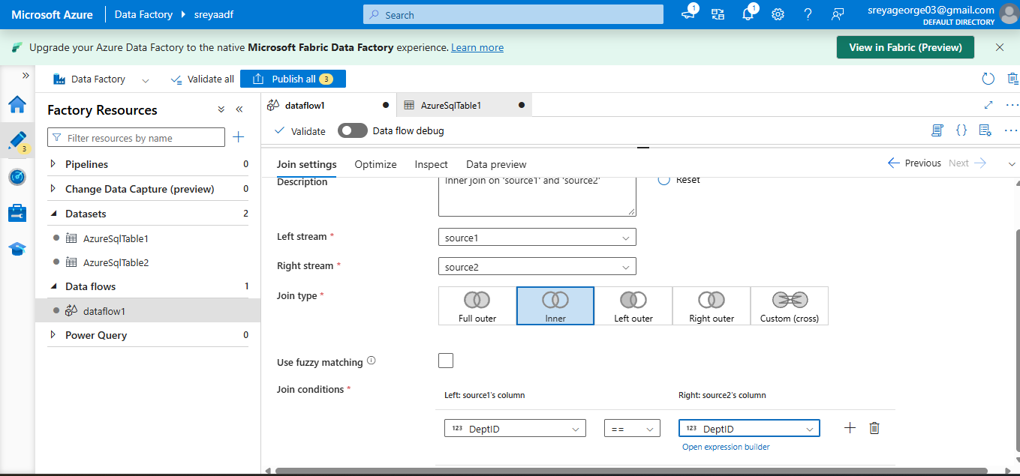
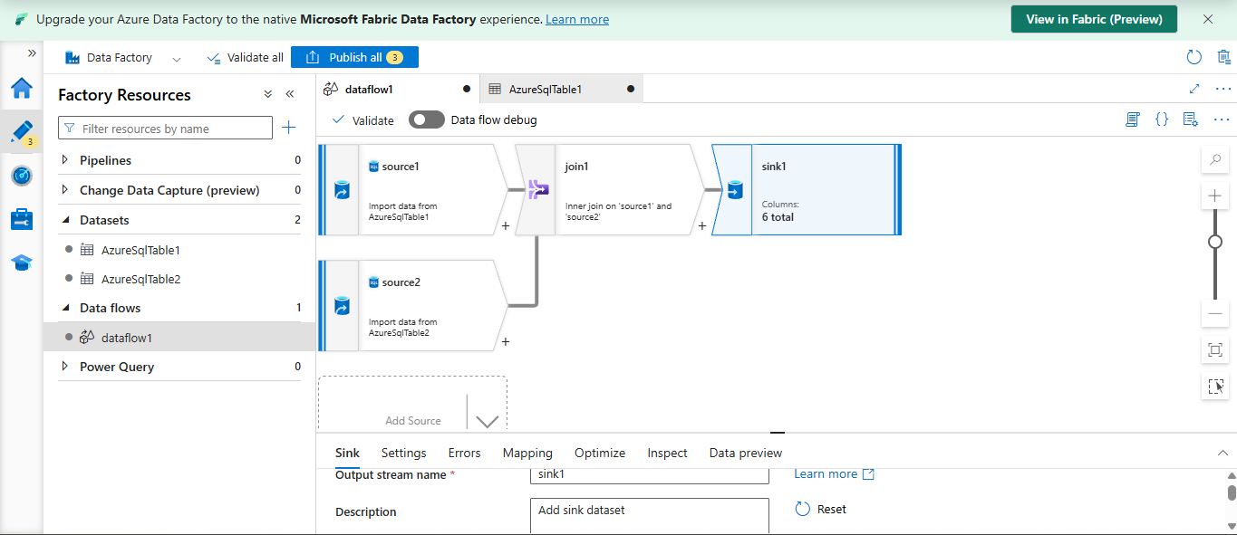
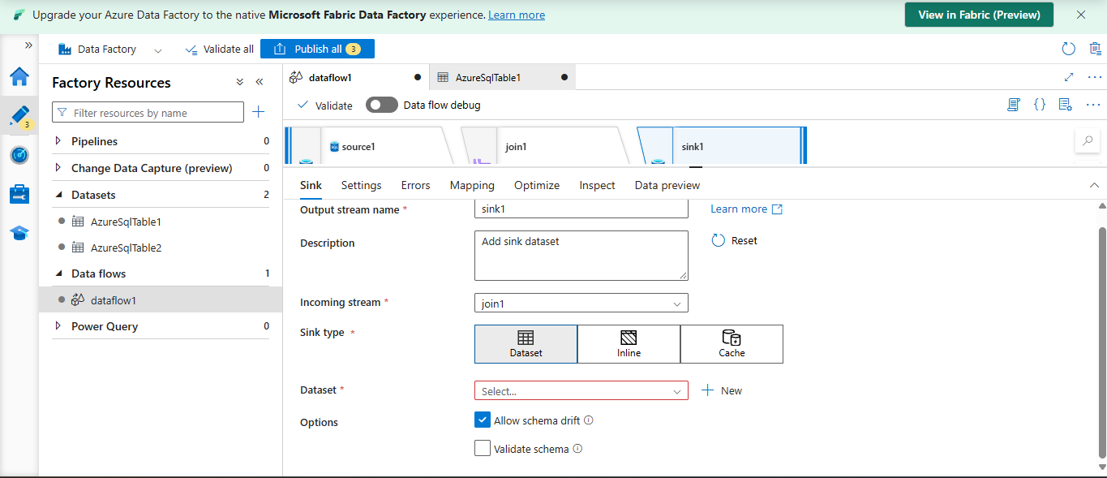
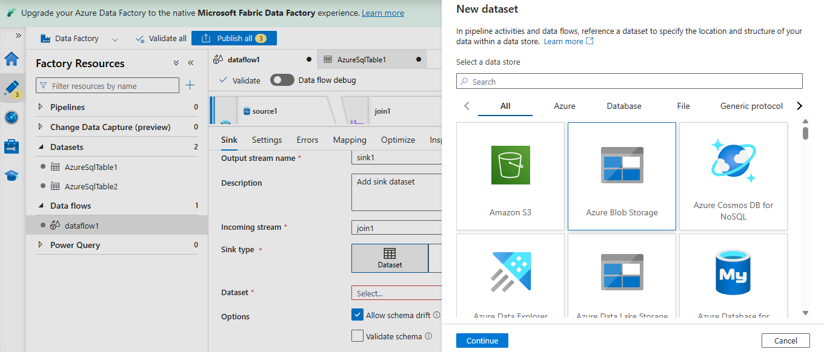
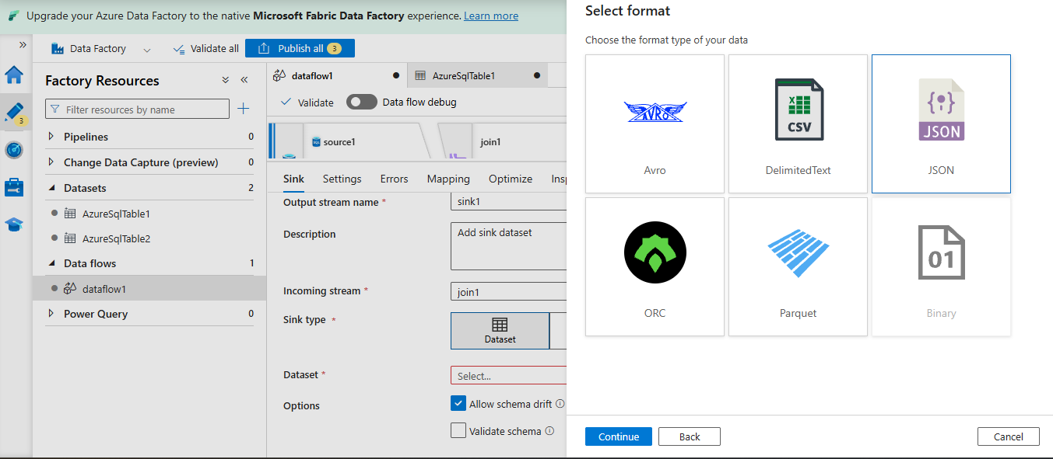
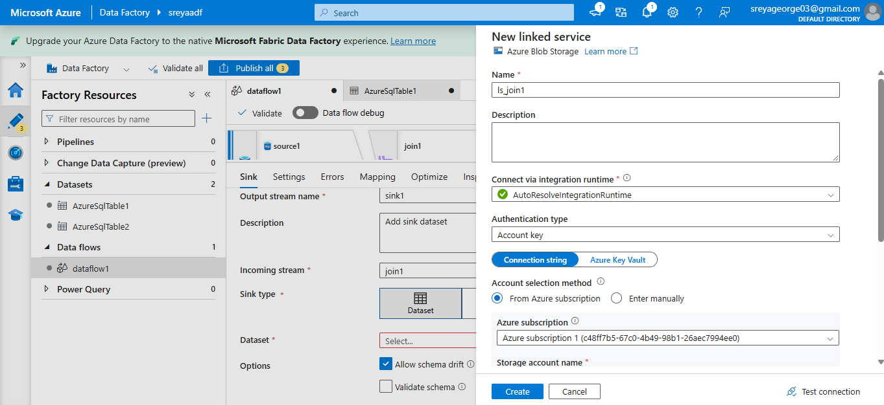
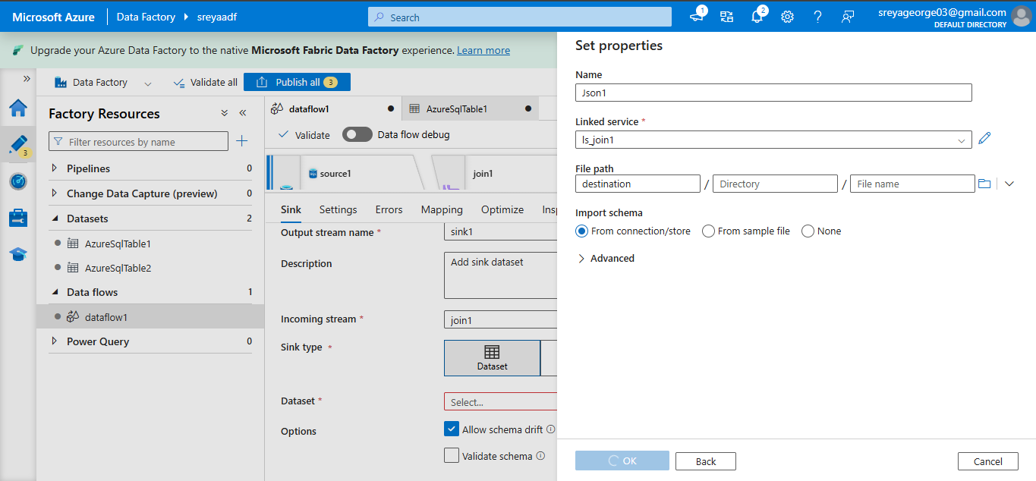
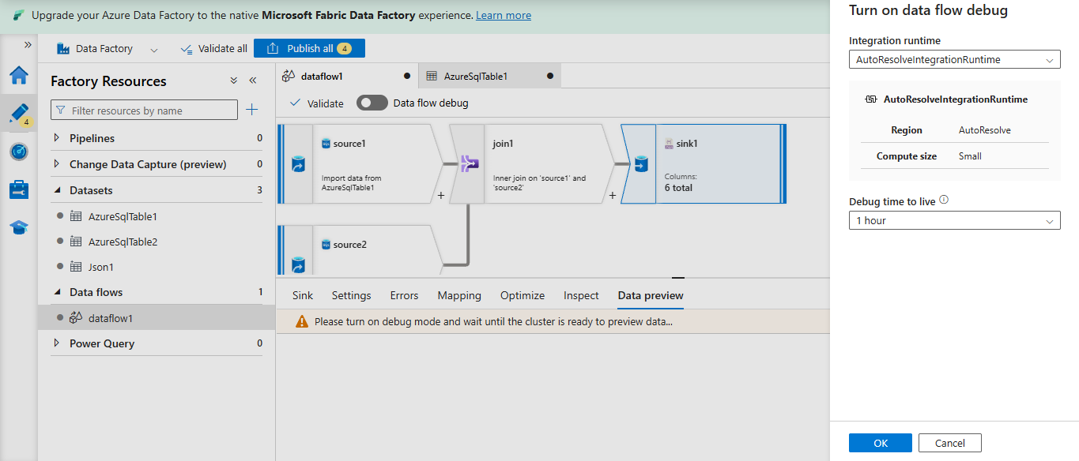
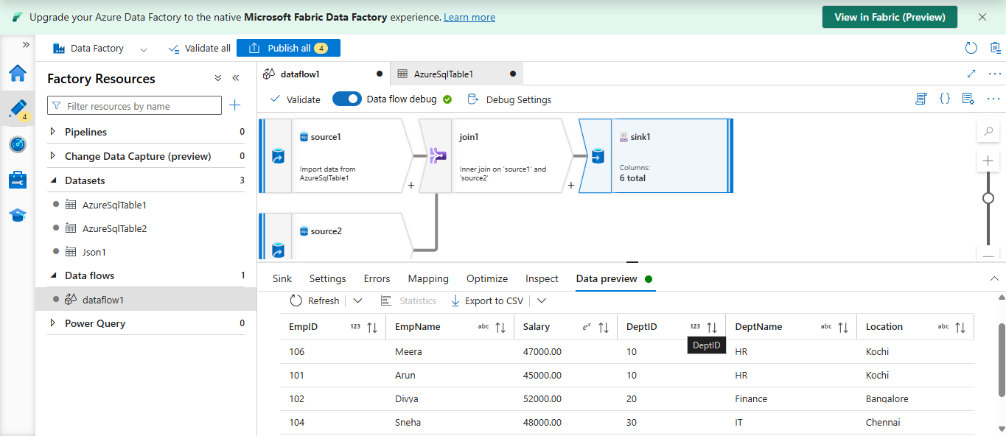
Make a new pipeline and paste dataflow in it
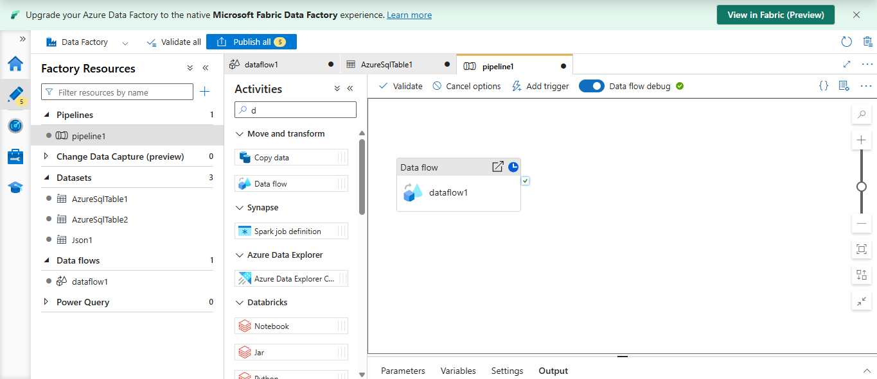
Validate and debug
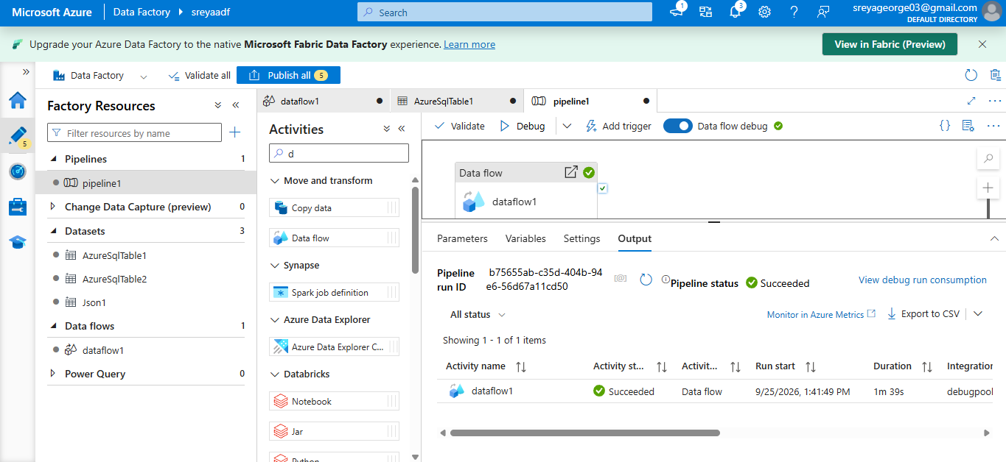
2.Union
